Results

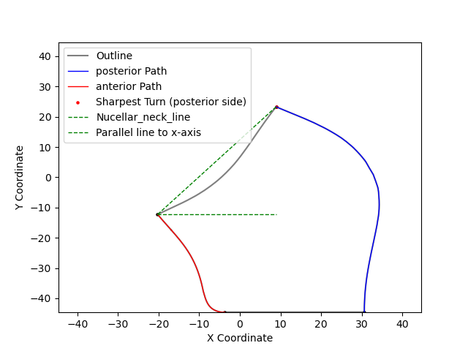

1. The outline points in .ply file:

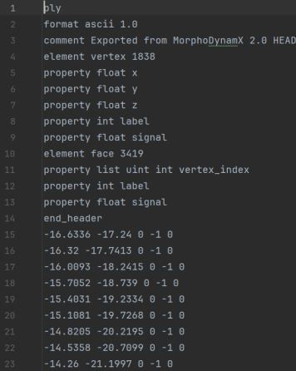Maybe because of using the same original points simulation template, the order to connect the points of outline and coordinates of the points crosse all samples are similar. So later I used some values to filter the points I need.

only the outline points has z = 0 (the 3rd number on one line)

1. Find the baseline edge points:

Find the most common y value below -40 as baseline and use it to find the leftmost and rightmost points of it.



# now

1. xmin_ymax point is up tip of anterior line; it should be always the leftmost (and then highest) point because of chalaza can grow freely on anterior side.



1. Find point on the mid of posterior line; which should has y value between -30 and -20 and find the rightmost point in that range (xmax_in_range point, which did not marked on image).



1. The sharpest turn should be between xmin_ymax point and xmax_in_range point which has the smallest angle in these range.



1. Use the sharpest turn point, baseline edge points, xmin_ymax point to draw the two paths and measure the length (by sum up each short distance of point to point by connecting order).
2. The kink angle is the angle between the X -axis horizontal line to the line of sharpest turn point to xmin_ymax point.
3. The calculation of this polygon area is based on Shoelace formula <https://en.wikipedia.org/wiki/Shoelace_formula>